Laboratory Report Book

|  |  |  |
| --- | --- | --- |
| **Laboratory** | **Date** | **Page** |
| Lab 1 | 1/17/17 | 2 |
| Lab 2 | 1/24/17 | 5 |
| Lab 3 | 2/6/17 | 10 |
| Lab 4 | 2/6/17 | 16 |
| Lab 5 | 2/21/17 | 18 |
| Lab 6 | 3/3/17 | 23 |
| Lab 7 | 3/21/17 | 29 |
| Lab 8 | 4/11/17 | 35 |

**ECE- 1270- Fall 2016 Lab 1: Introduction to MATLAB**

**River Schenck 1/17/2017**

**Objective:**

This lab will introduce students to some of the capabilities of MATLAB. Students are advised to try different things and analyze the outcomes to expand their learning beyond the basics required for this lab.

**Preliminary:**

Watched the videos on MATLAB to become more familiar with it.

**Procedure:**

**Part 1**

t=0;

for x=0:0.1:2*pi

t=t+1;

y(t)=5-4*exp(-0.5*x)*cos(2*x);

end

figure(1), plot(y)

x=[0:0.1:2*pi];

y=5-4*exp(-0.5*x) .* cos(2*x);

figure(2),plot(x,y)

xlabel('Time(s)')

ylabel('Voltage(V)')

title ('v(t)')

**Part 2**

A=[(-1/5)+(1/4j),(1/5)+(1/6)-(1/7j),(1/8j)-(1/4j);(1/3j),(-1/6),0;(2),-3,1]

B=[(1/8j)-(1/4j),(-10.5+(3/1j)),0]

inv(A)*B

[ang,mag]=cart2pol(real(ans),imag(ans))

angdeg=ang*180/pi

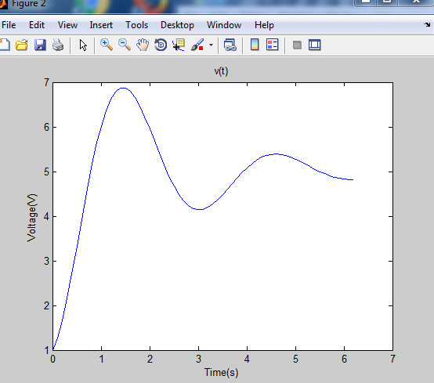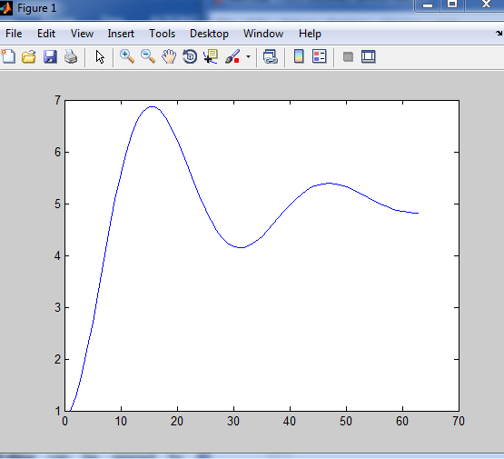

**Conclusion:**

This was one of my first times use code so I was not very good at it at first. I eventually caught on. I needed to learn these concepts because we are going to be using them again in about two weeks. I learned what for and while meant and how to create a loop.

**ECE- 1270- Fall 2016 Lab 2: RC Circuit**

**River Schenck 1/24/2017**

**Objective:**

Introduction to the time variations of voltages and current in circuits made up of resistors and capacitors (RC).

**Equipment and Components:**

1) Breadboard, Multimeter, Power supply, Signal Generator, Oscilloscope

2) Resistors: 500 Ω and 10 kΩ

3) Capacitors: 0.1 µF

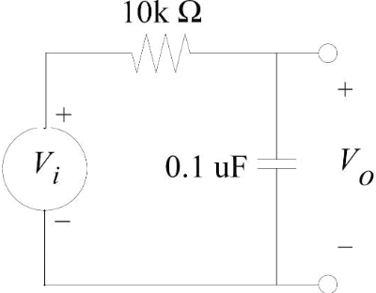

Figure 1: RC Circuit

**Preliminary:**

1. Calculate the time constants for the circuit shown in Figure 1.

.001s (10K) 50 micro s (500)

1. Use the transient analysis of a circuit simulator to determine the output voltage, Vo, for the following Vi : 0 to 5 V square wave with a frequency of 50 Hz.

*For Multisim:* With R=500 Ω, set Vi to a Pulse Voltage source with initial value = 0 V, pulsed value = 5 V, delay time of 0 sec, rise time = 1 us, fall time = 1 us, pulse width = 1 ms, period = 2 ms. You may also use any Spice for simulation.

1. Repeat the above for R=10 kΩ (adjust the voltage source as rise time = 0.1 us, fall time = 0.1 us, pulse width = 10 ms, period = 20 ms).
2. Calculate the cut-off frequencies for the two circuits (see the note at the end).

160 Hz (10K) 3180 Hz (500)

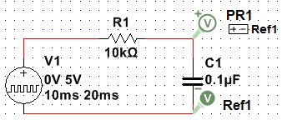

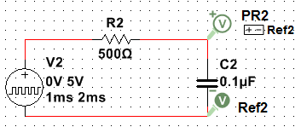

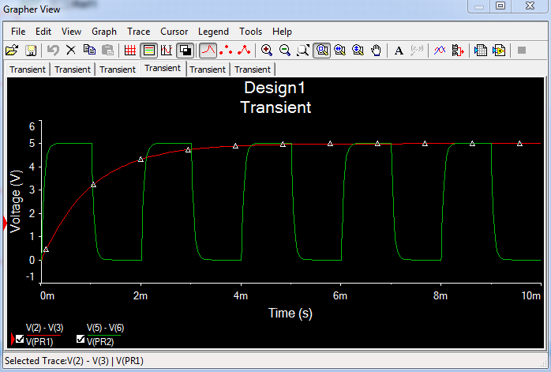

**Procedure:**

**Time Domain,**

Create the circuit shown in Figure 1. Apply a 0 to 5 volt, 50 Hz square wave and measure the time constant τ (about 1 ms) of Vo with an oscilloscope by two methods:

1. The time it takes the waveform to traverse one time constant.

HINT: This would be at 63% of the maximum value during its charging or 37% of the maximum value during its discharging cycle.

1. Extending the initial slope of the exponential.

HINT: During the charge or discharge cycle, place a straight edge at the point where the voltage/current starts to deviate from linear response. 

This was an interesting way to measure the time, we used the cursors on the oscilloscope and were able to measure the slope to be 640 µs to traverse one 𝒯. The calculated value was 630 µs so that makes for fairly accurate measurement.

**Frequency Domain**

1. With R=500 Ω, use a sinusoidal source of 1 V amplitude and vary the input frequency from 10 Hz to 100 kHz. Record the variation in peak value of Vo at a minimum of 10 different frequencies (i.e. 10 Hz, 50 Hz. 100 Hz, 150 Hz, 200 Hz, 300 Hz, 500 Hz, 1 kHz, 10 kHz, 100 kHz). Plot Vo peak with respect to the input frequency in your lab book. Measure and record the frequency at which the amplitude of the output voltage drops to 0.707 times its amplitude at lower frequency (e.g. 10 Hz).

Table Below

1. Repeat the above for R=10k Ω. Which one of the two circuits has lower cut-off frequency?

Table Below

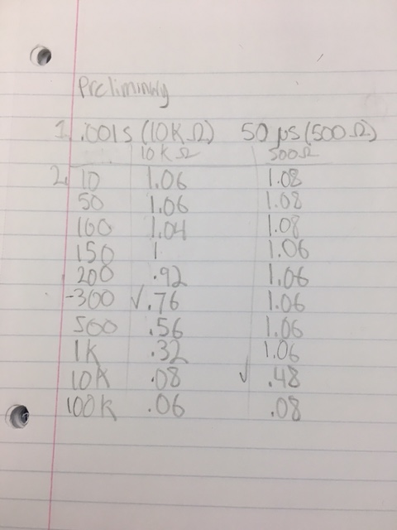

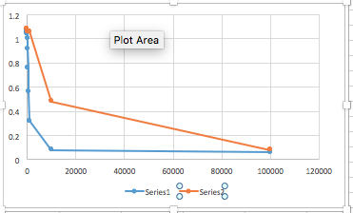

**The following extra measurements may help you to explain the discrepancies between the calculations/simulations and the experiment:**

a) Use a multimeter to measure the value of the resister used.

b) Thevenin resistance of the source must also be accounted for source (Rs = 50 Ω). Account for all three resistors (1 physical, 1 wire, 1 source).

c) Using an LC bridge, measure the capacitance of the capacitor.

**Conclusion:**

|  |  |  |  |  |
| --- | --- | --- | --- | --- |
| **C=0.1*μ*F** | | | | |
| **Resistor Value** | **Time Constant τ** | | **Cut-off Frequency *f*** | |
| **Calculated** | **Measured** | **Calculated** | **Measured** |
| **R=500 Ω** | .5u | .6u | 3180 HZ | 4000 HZ |
| **Rmeasured =** |
| **R=10 kΩ** | 630 µ | 640 µ | 160 Hz | 250 Hz |
| **Rmeasured =** |

Give plausible reasons for discrepancies between calculations, simulations, and laboratory measurements. Include a discussion about the effect of source and effective resistance on calculated time constants and the accuracy of the LC bridge. Use a table to display each test results and errors from

expected values.

Possible reasons for discrepancies could be that our resistor was not exactly 500 Ω. I was a bit more that 500 Ω. We kept having problems with our circuit. We realized that whenever when put the ground in the oscilloscope would stop getting values back. We finally realized that this was the noise and that when we grounded it that is when it went away. We just needed to turn on the channel. Even after that we did not get the correct values. We then found that we did not have high impendence on. Once we changed that we started to get the correct results.

**ECE- 1270- Fall 2016 Lab 3: RLC Circuit**

**River Schenck 1/24/2017**

**Objective:**

Introduce RLC circuits to develop a familiarity with critically damped, over-damped, under-damped situations, as well as rise time, overshoot, and settling time.

**Equipment and Components:**

* Prototyping board, Multimeter, Signal Generator, Oscilloscope.
* Resistors and/or potentiometer: value to be determined
* Inductor: 1 mH
* Capacitor: 0.01 uF

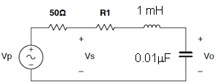

Figure 3.1: Series RLC circuit

**Preliminary:**

1. For the series circuit of Figure 3.1, find the resonant frequency ωo and calculate the size of the resistance R1 that will make the circuit critically damped.

Resistor for critically damp is found by R = 2LLC=582 Ω Wo = 316,227RadSec

1. Approximate the value of R1 for a critically damped, underdamped and overdamped circuit.

As stated in step 1, critically damp is about 582 Ω, for the under and overdamped take your pick! We chose to 300 Ω and 5kΩ for the over and under damped circuits.

1. Find the approximate damping ratio ζ for each R1.

|  |  |
| --- | --- |
| Type | Zeta |
| Critically damp 582Ω | 0.92 (not 1 because we adjusted 50Ω out to account for function generator resistance. |
| Underdamped 30Ω | 0.047 |
| Overdamped 5kΩ | 7.9 |

1. For the underdamped case, compute the percent overshoot for Vo for the underdamped case. Also, compute the settling time for Vo to reach 10% of its final value.

For a resistance of 550 Ω the overshoot was 0.0078% and the undershoot was 11.519µ seconds.

**Procedure:**

1. Build a circuit according to Figure 3.1 with R1 being a fixed resistor plus a potentiometer. Apply a square-wave signal as the input. Monitor both input and output with the scope. DONE!
2. By adjusting the value of potentiometer, obtain and record 3 responses: critically-damped, overdamped, and underdamped, respectively. Measure and record R1 in each case.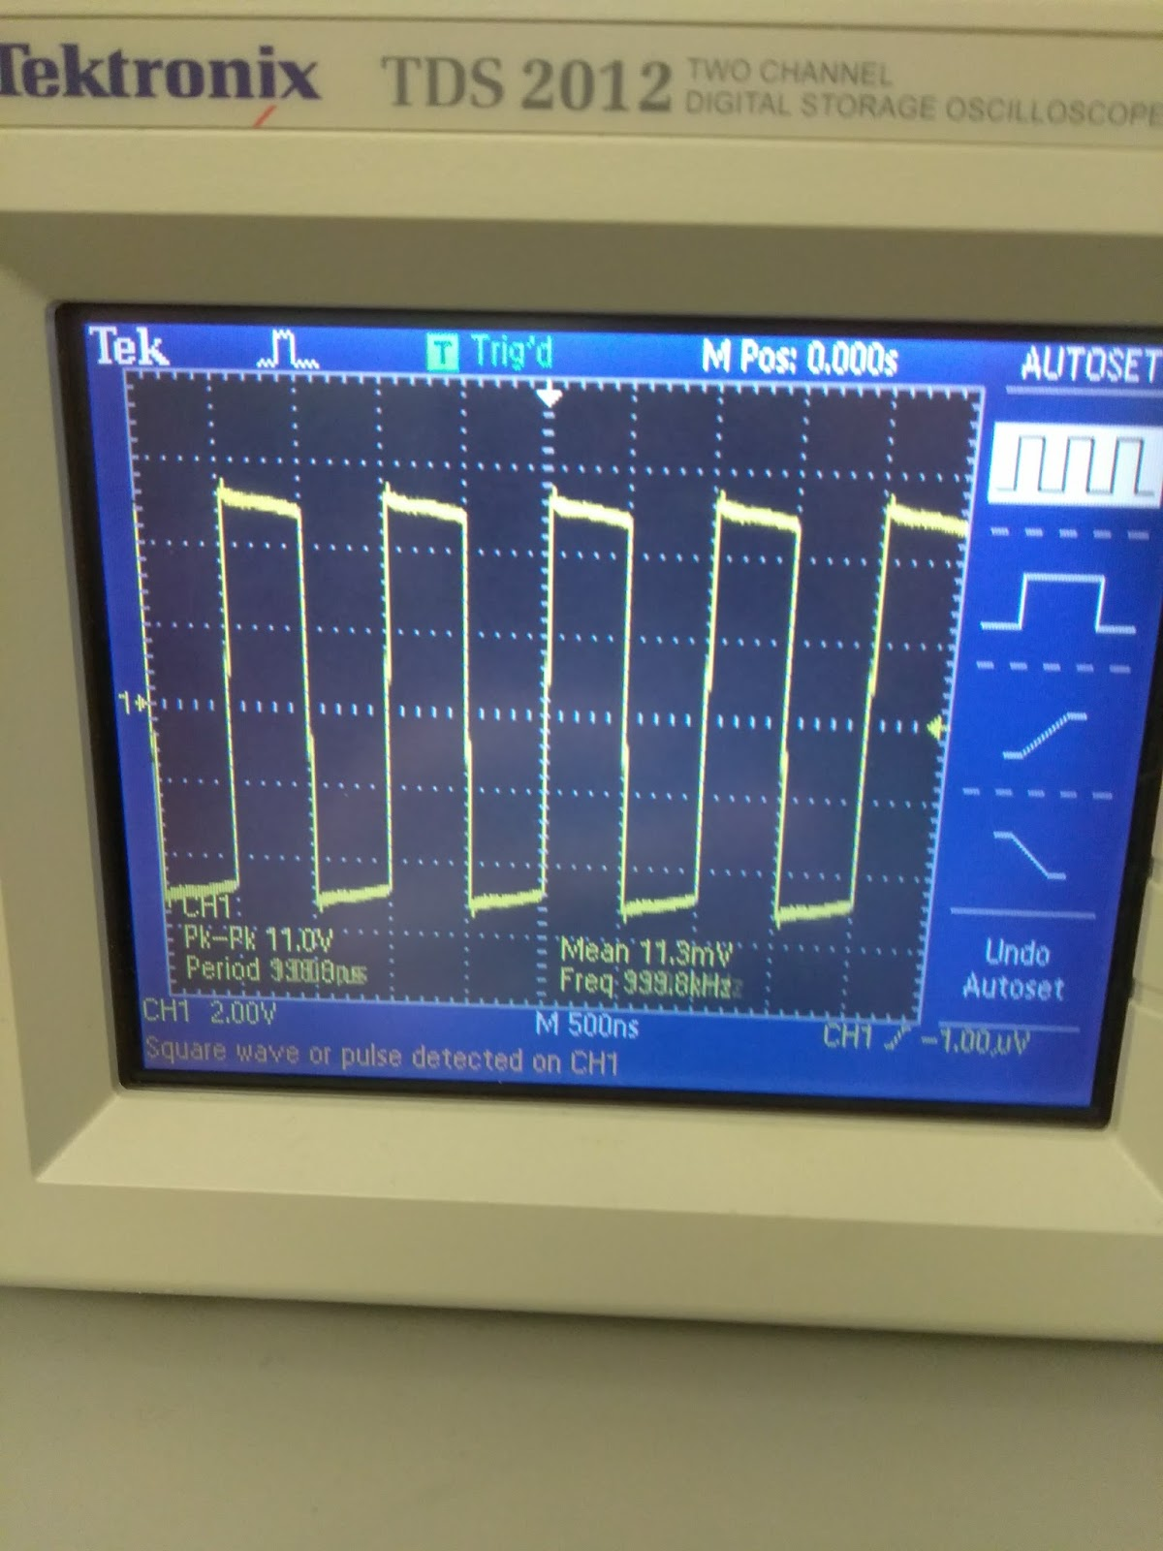

Above is a picture of the underdamped circuit, you can see it just starting to wiggle at the peaks.

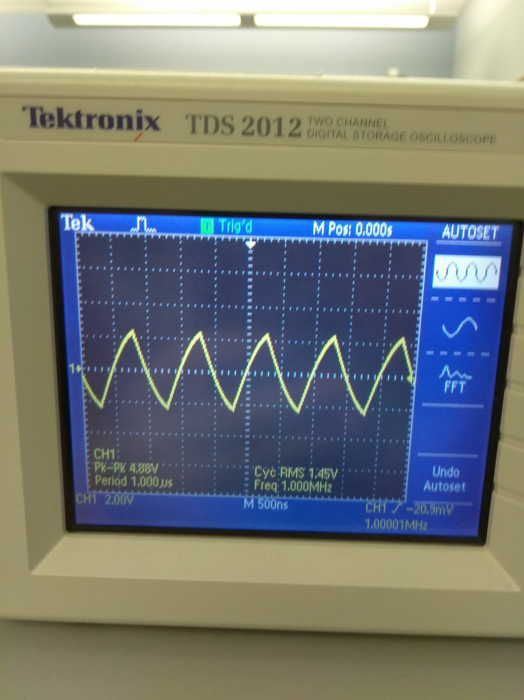

Above is a picture of the overdamped circuit. It turned the square wave into a sawtooth wave.

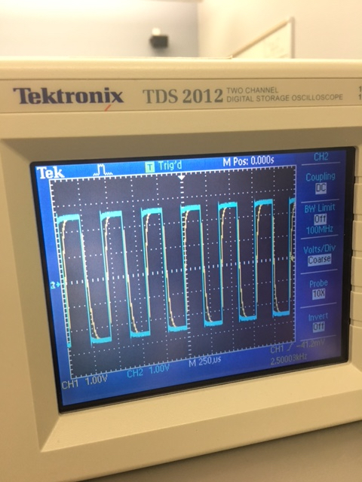

This is an image of a critically damped wave vs the input box wave.

1. For the underdamped case, measure the rise time, overshoot, and settling time.

Using the oscilloscope we found that the underdamped circuit we built using 30Ω, we measured a rise time of 280 nanoseconds.

Overshoot is calculated using the formula below. Using zeta as 0.047 the overshoot comes out to be 86.2 percent.

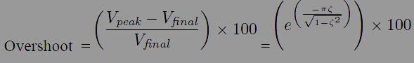

Calculating the settling time is calculated using the formula below. Inserting our zeta once again we get a settling time of 203µ seconds.

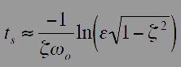

**Conclusion:**

Use Multisim to simulate and verify your experimental results. Include a table to compare your calculated and simulated values to the measured values. Write a conclusion to discuss your observations.

|  |  |
| --- | --- |
| **Calculated Resistance** | **Measured Resistance** |
| Underdamped 300Ω | In practice 30Ω (until visible) |
| Overdamped 2kΩ | 5kΩ |
| Critically damped 582Ω | 632Ω |

The discrepancy between the critically damped values is from the internal resistance of the function generator. For the underdamped case, the circuit is certainly underdamped for values lower than 582Ω but we just could not see it visually on our oscilloscope. It was interesting to note the visible differences between the 3 different cases.

**ECE- 1270- Fall 2016 Lab 4: RLC Impedance (Matlab)**

**River Schenck 1/24/2017**

**Objective:**

Use Matlab to plot the “impedance vs. frequency” curves for the parallel and series RLC circuits.

**Procedure:**

Write a Matlab script with the following features:

1. Let the user input the R, L, and C values.
2. Calculate the resonant frequency,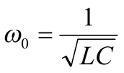.
3. Calculate the impedance for the series RLC circuit 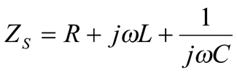for https://lh5.googleusercontent.com/dpGqm_QeSYAnWfTYdmbaSW4fSRRScKA3x3NHCNuoMFnliu4VRrdneHxB6hjY-bxeysvmkq746xgrm7nH9qSMoHPaSr3MgJwBvvR2Ij52Rn3y0MTdNgTLrsC1zUTnM6xx8vvpwdgO
4. Calculate the impedance for the parallel RLC circuit 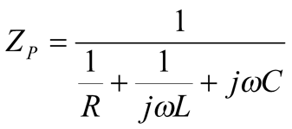for https://lh3.googleusercontent.com/UcpOw3WRWNNf0INVWaWJe0-B9fSxqcKH7McLR73HMtZq_ikEpXh_DkBfBrAj247Ma8UKeU65K8VpZnVkKR4QVdb5R6D9v3fvFrK9crYMkZQuu4Ao_dVTnKUkwK8n7G975wn1JA1D
5. Plot the curves of |ZS| vs. ω and |ZP| vs. ω (see the appendix for an example code).

**Conclusion:**

Write a report to include your code, plots, and observations (What is the minimum impedance for the series circuit? What is the maximum impedance for the parallel circuit? Do you know why?).

The minimum impedance for the series circuit is 2.5x10^4 Hz. The maximum impedance for the parallel circuit is 7.5x10^4 Hz.

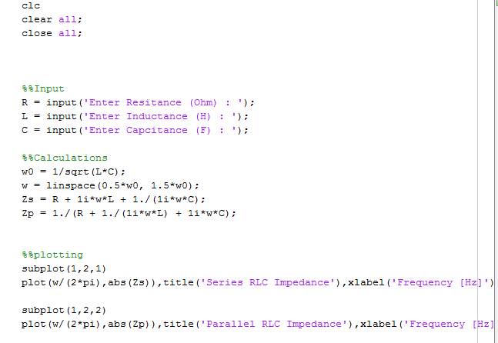

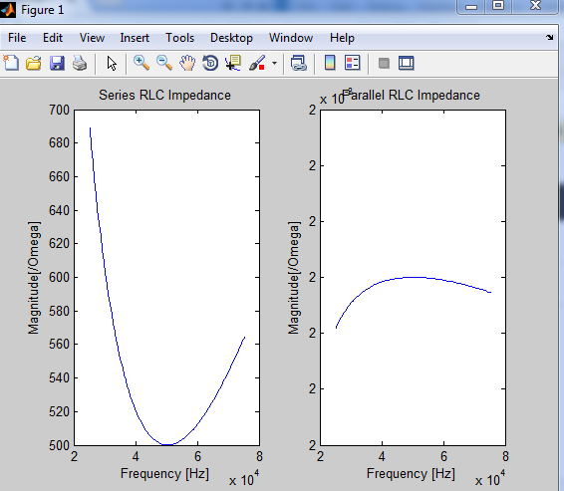

**ECE- 1270- Fall 2016 Lab 5: Inverse Laplace Transform via MATLAB**

**River Schenck 2/21/2017**

**Objective:**

The Laplace Transform converts the integral-differential equations of electromechanical system into algebra-based equations that can be easily manipulated. However, evaluating the inverse Laplace transform can be cumbersome. This lab will introduce some tools in MATLAB that can be used to find the inverse Laplace transform.

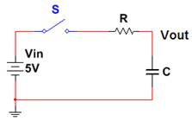

Figure 5.1: Series RC circuit to be analyzed

**Pre-Lab:**

Read section 13.2 from Nilsson & Riedel and understand how to convert R, L and C in time domain into s-domain, as shown below.

**Procedure:**

In Figure 5.1, select your own values of *R* and *C*.

The switch closes at t = 0. The output (*Vout*) is the capacitor voltage.

Once converted to frequency domain, all components can be treated like “resistors”. Treat all components like “resistors” and solve for *Vout(s)* in the Laplace domain.

The voltage divider gives 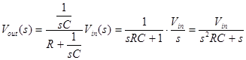.

The time-domain solution *Vout(t)* requires us to find the inverse Laplace transform *Vout(s).*

Find the inverse Laplace transform using the following 2 methods:

**Method 1**: Using the MATLAB built-in function residue

Let the denominator be https://lh5.googleusercontent.com/rlnNPxsJkIREwZoQzCq3bXDqBWMVB0fPRHBnOU-LWDTQ34J90S17MPiHGLSRjqCmhMJA9-KlqjzDs19kjjayxGrL1qnXls_-1kJxIMsilyO8uKUDvavjIjHF9s_AV0F7W1V1G64fand the numerator behttps://lh4.googleusercontent.com/B0OM3znMibkrzlujBAfpb3ZATVZ847ezZmJD2RrMJEBgG8lE4C8ehwxxnSC8ELjrdFXTz7iwturozXYOrPqjZ00mRkn_eonUjsOE1HDGlCbweMCBgGBAl4OUgR7_ID6EzkLkgSEP

Then the MATLAB function [r, p, K] = residue(b, a) finds the partial fraction expansion:

https://lh6.googleusercontent.com/WVt2UK_d5Vc5c6HM_XlwkdFz4PnqG2an7Qe3EuzsIWCRibqXp0vnwjVjOnpykqtuMNyWJnK986d6OIxHpVPPxhp1pOCcainLyASgHi2zICFChSeE9feNXg8Gn--0LrrdResEmL6d

Once the partial fraction expansion is obtained, you can write down the inverse Laplace transform:

https://lh6.googleusercontent.com/94HlLovKMgHtMuee1_-E7EVxM0stb93iUe46GtUaGhVX-uZfIxKoDiFyLzwuY6N7b9-J9VbSOl3nJvoXrYddm-csyJxh8Zx9Hjj2dW2s012oVwwNtNr5W3trbI-NPbT1c3wQAu63

Here we assume that we have only simple poles. When the order of the numerator *b* is lower than the order of the denominator *a*, we always have *K* = 0.

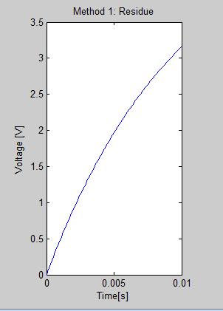

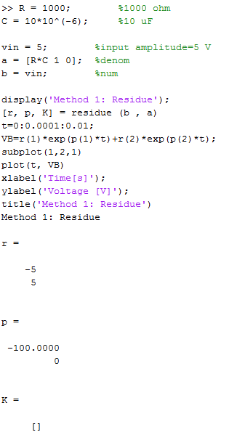

**Method 2**: Using the MATLAB’s symbolic calculation and function ilaplace

As an exercise, run the following MATLAB script to learn about MATLAB’s laplace and ilaplace :

syms t       %time variable t

f=2*exp(-t)-2*t*exp(-2*t)-2*exp(-2*t);  %define f(t)

pretty(f)    %looks better

F=laplace(f)     %Laplace transform

pretty(F)    %looks better

F=simplify(F)    %combine partial fractions

fnew=ilaplace(F) %inverse Laplace transform

pretty(f)     %looks better

Now you are ready to do the lab using the second method.

i. Defining the symbolic variables to be used (i.e. *s*)

>> syms s

ii. Writing the Laplace domain function

>> F = b/(R*C*s^2 + s)

iii. Operating on the function

>> f = ilaplace(F)

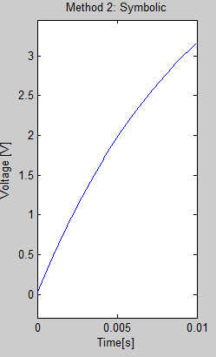

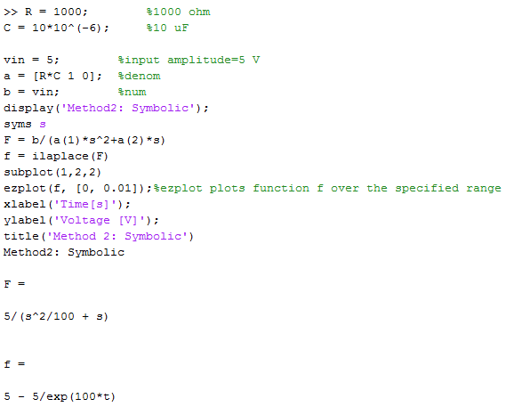

**Post-Lab:**

1. Did the two methods give you the same mathematical expression for the inverse Laplace transform? Yes we got the same equation. Our graphs were exactly the same also.
2. Type (or write) the two time-domain expressions in your conclusion.

Method 1: f(t)=5-5/exp(100*t)

Method 2: f(t)=5-5/exp(100*t)

1. Run a *Multisim* simulation to verify the time-domain *Vout*(*t*) is reasonably correct.

Done.

**ECE- 1270- Fall 2016 Lab 6: S-domain Circuit Analysis**

**River Schenck 2/21/2017**

**Objective:**

To learn how to use MATLAB Symbolic Computation to solve the S-domain circuit problems.

**Pre-Lab:**

1.      Find v0(t) for the circuit in Fig.6.1 using the following analysis methods in s-domain:

a.      Mesh Analysis

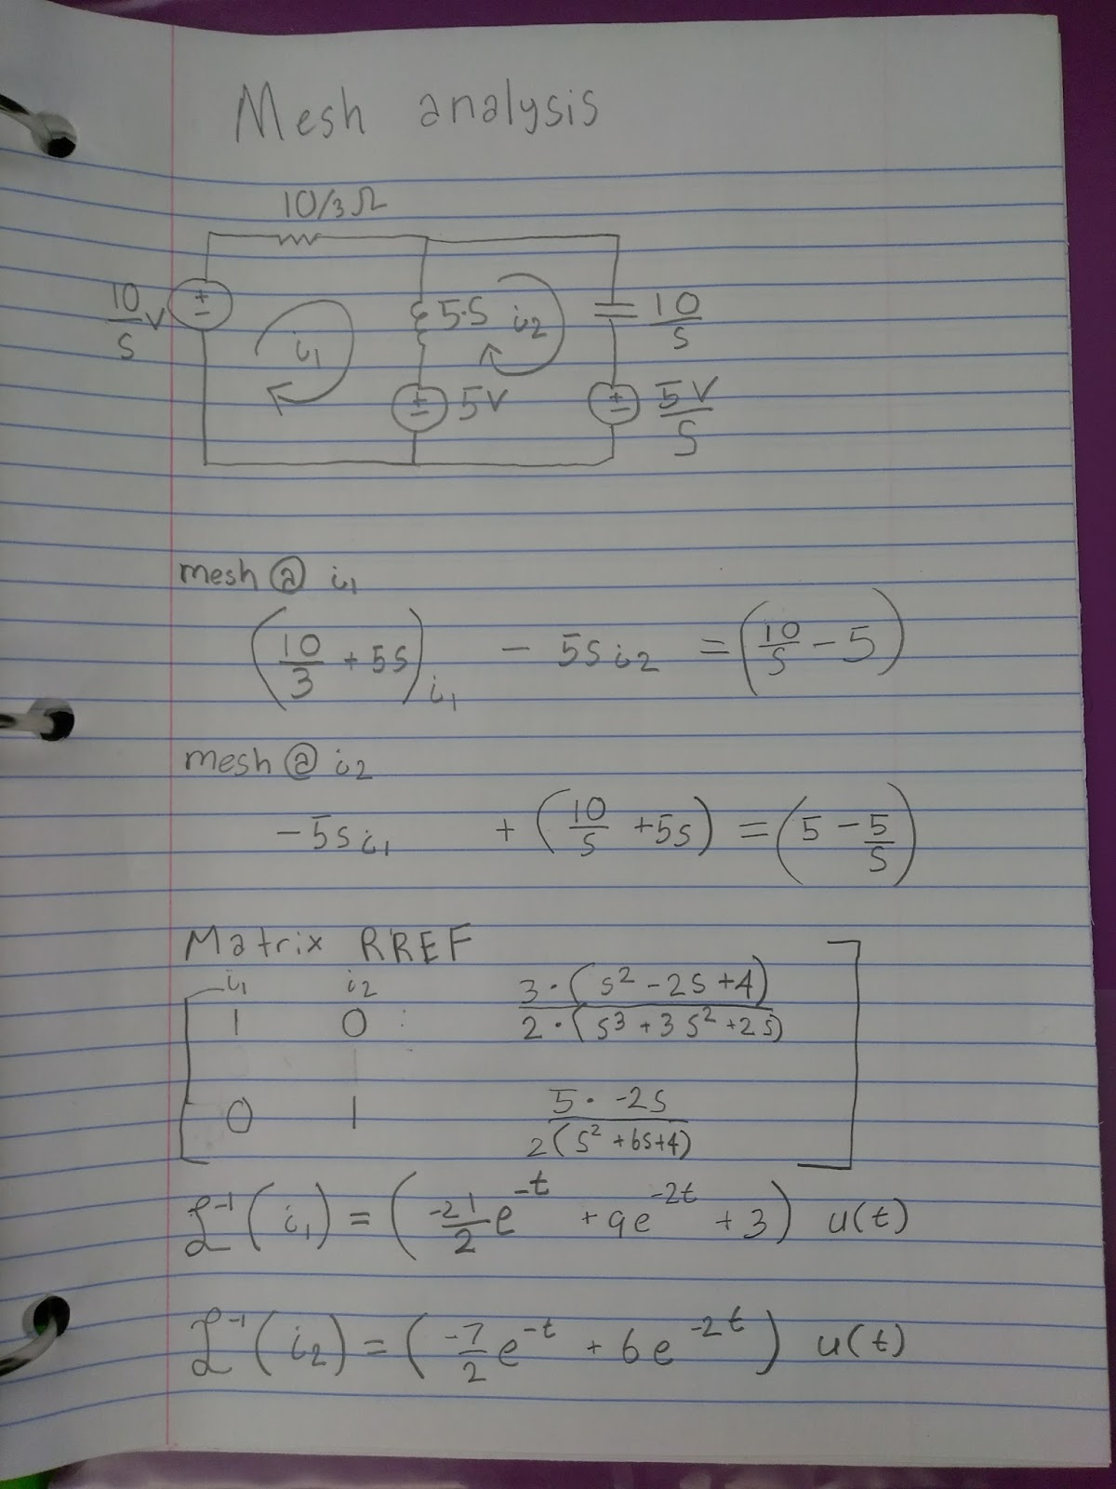

V(o) = (35e^-t -30e^-2t) u(t)

b.      Superposition Theorem

2.      Determine the transfer function H(s) for the circuit.

3.      Solve AP13.9 from Nilsson & Riedel

Fig. 6.1 RLC circuit with *vs(t)* = 10u(t) Volts                 Fig. 6.1 AP 13.9, 13.10

**Procedure:**

**PART 1: Use Symbolic Toolbox to find time-domain solution**

1.      Solve the multiple mesh circuit in Figure 13.16 of Nilsson & Reidel as an example.

The book sets up a system of equations in the S-domain as

Write a short MATLAB symbolic script (see the Appendix) to solve the problem and find the time-domain solution. Compare your result with the book’s solution:

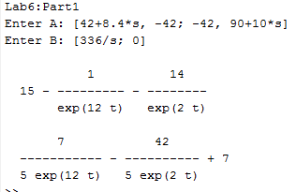

2.      Update the Matlab code to accept user inputs for A and B. Using the code, solve the s-domain mesh analysis equations for the circuit in Figure 6.1.

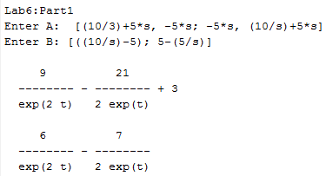

*Hint:* Use 3 equations with 2 mesh currents and the voltage V0 as the variables.

3.      Now, using your code, find the portion of *v0(t)* due to each of the s-domain inputs and use superposition theorem to find the total *v0(t).*

**PART 2: Find Unit Step and Impulse Responses using Transfer Function**

1.      Solve AP13.9 and AP13.10 using transfer function in Matlab.

**AP13.9 (transfer function)**

First, derive the transfer function ***Vo/Ig***. Next, build the transfer function in Matlab.

The simplest way to do this to define the numerator and denominator coefficients as vectors and use **tf** as follows:

num=[0 1 2];

denom=[3 4 5];

H=tf(num,denom)

**AP13.10 (unit step and unit impulse responses)**

Matlab has built-in step and impulse response functionality. Just type

figure; step(H)

figure; impulse(H)

You will see plots showing the unit step and unit impulse responses.

***Note that the unit impulse response shows the transfer function in time-domain.***

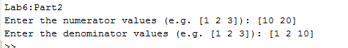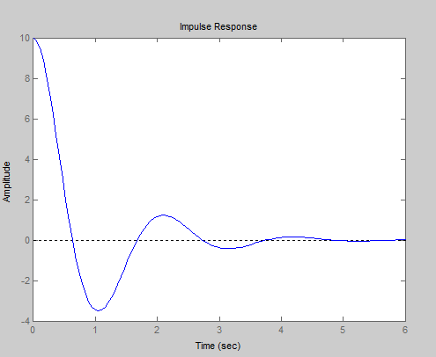

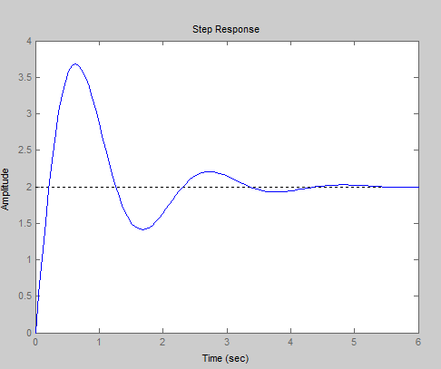

2.      Using the Matlab code, verify your transfer function from Pre-lab #2.

https://lh5.googleusercontent.com/mAYRnrrgMcYjzR6lHj9K9-i_O7OazA4br4FNZjaYzsZzzKhy_2NUmnimJA2xZPzhz8Etr5YHZTu3zeix6fOjjtiESrCKTIXePJstjR8eYwDRjHT8wSJuwWpCPJ2EyLJZf_R8HBBT

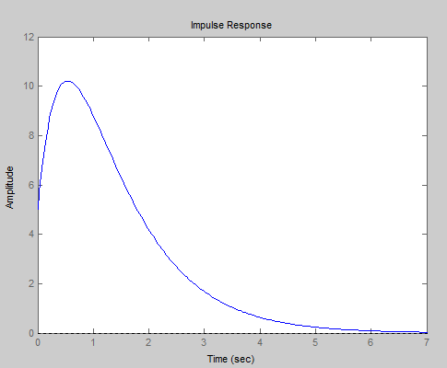

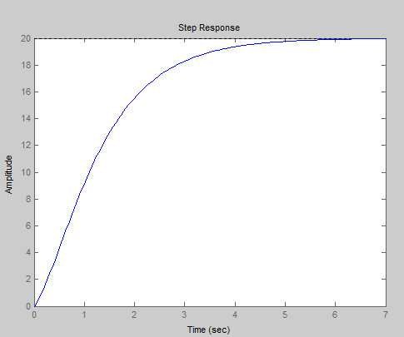

**Conclusion:**

Comment on your experience using Matlab to solve s-domain circuits and finding transfer function with respect to solving them by hand. What are the key things to keep in mind to generalize your code so that it may be applied to multiple circuits or systems?

Using matlab to solve s domain circuits is easier than it sounds. Using matlab to find the transfer function is a lot easier than by doing it by hand. I was very impressed by the graphs that were made. Some ley things to keep in mind to generalize the code is to keep it simple and readable. It makes it easier if you comment on lines so you know what the function of that line is.

**ECE- 1270- Fall 2016 Lab 7:Audio Crossover Networks**

**River Schenck 3/21/2017**

**Purpose:**

In this lab, we will learn about the physical application of transfer functions and how they can be used to mathematically represent electrical systems such as the sub-woofer and tweeter networks.

**Background:**

In audio applications, engineers are usually concerned about the efficient transformation of energy from an electrical signal (***V***, ***I***) to a sonic signal (differing air pressures). Speakers are commonly designed for a limited dynamic range of sound. Woofers usually cover 35 Hz – 3.2 kHz, Tweeters commonly cover 2 kHz –30 kHz, and the Mid speakers overlap both and commonly address frequencies between 200 Hz – 4 kHz. Rather than sending the entire signal to different speakers, crossover networks are used to increase and/or decrease the effective impedance of each speaker, thereby increasing and/or decreasing the power sent to that speaker. Note that the cut-off frequency for each of the networks shown below is, 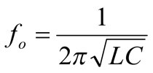. The LC configuration creates a low pass filter and CL configuration creates a high pass filter.

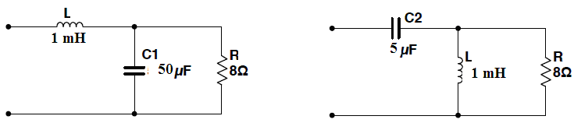

**Fig. 1: Sub-woofer Network            Fig. 2: Tweeter Network**

***First make a note of the actual values for the inductor and the capacitor available in the lab before proceeding. Note that* R=8 Ω *is the speaker.***

**Procedure:**

**Step 1 (Transfer Functions)**: Assuming that each speaker can be represented as an 8 Ω resistor, derive the Transfer Functions for Figs. 1 and 2 by the ***voltage divider*** method, referring them as *FL* (filter low) and *FH* (filter high), respectively.

**A:** **Sub-woofer Network**

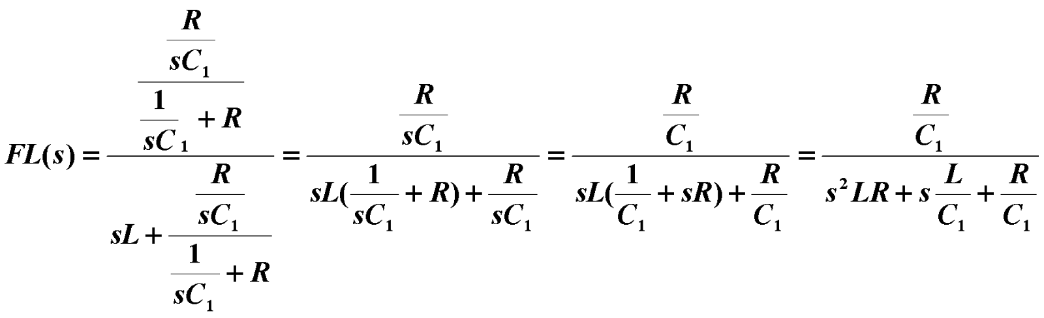

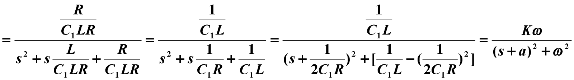

Where,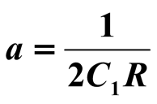,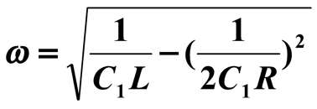, and 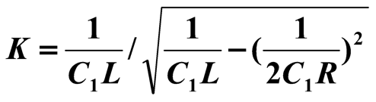.

***We will use the following version for the Matlab simulation*,**

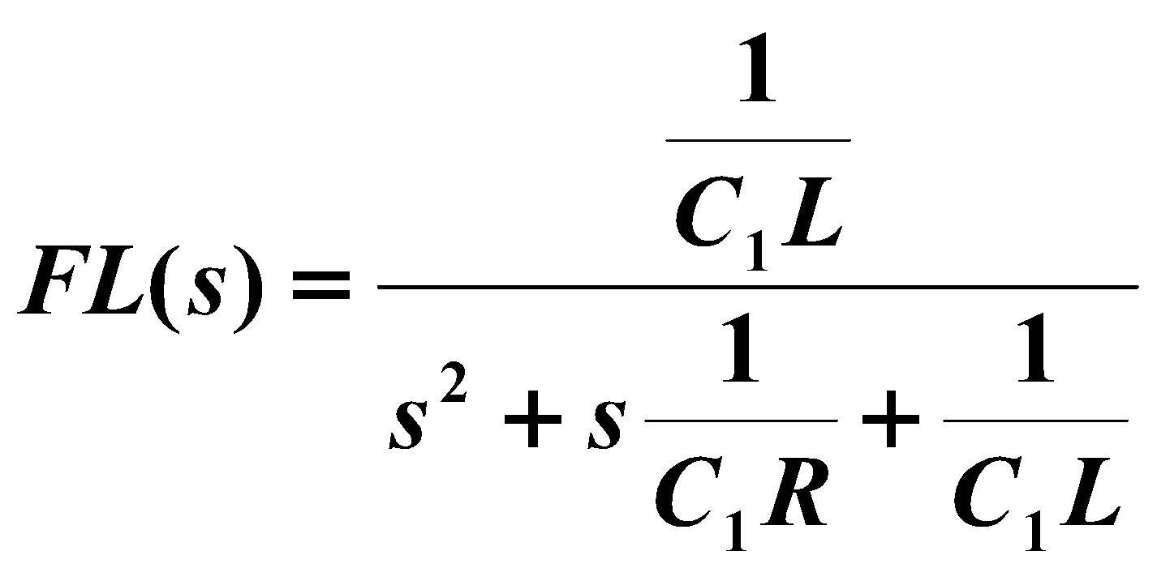

**B:** **Tweeter Network**

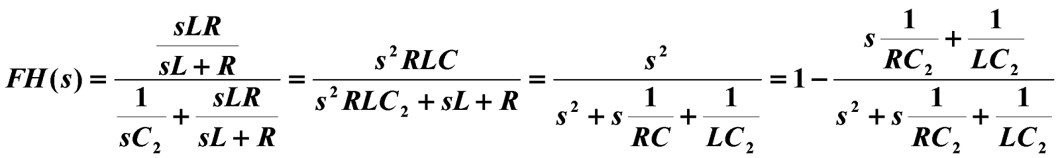

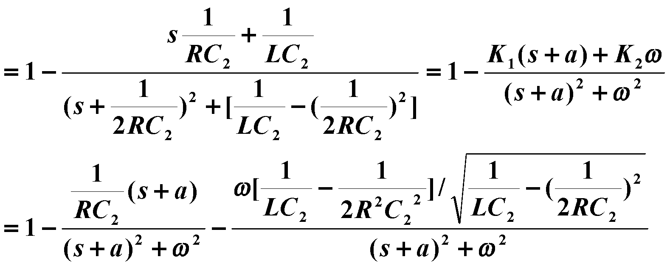

Where,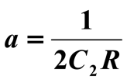,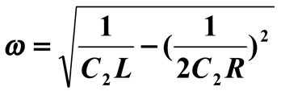,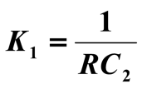, and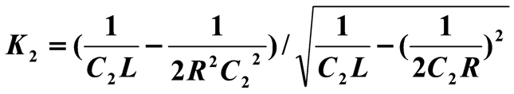.

***We will use the following version for the Matlab simulation*,**

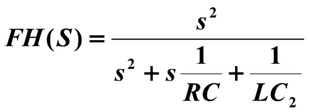

**Step 2 (Time-domain):** Convert the two transfer functions to the time domain, i.e. calculate the ***Impulse Response*** for the circuits in Figs. 1 and 2.

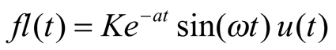**and https://lh3.googleusercontent.com/uyO1g5gw1fm3eojWT6dMFpoLP8PqOtLhpGBtXx5bYEmkxjsdtKJPwK113OYLFnn92VmXgtOz0rWbU_zAA7IBB2_fnIxV4v9qgEG5MuD4pC3SqXdanOZ3yU0AEfXQ29uCazy6C5oE**

**Step 3 (Circuit Simulations):** It is helpful to understand how this circuit will change with respect to frequency variations. Rather than conducting repeated transient analysis and recording the variations in amplitude and phase (Phasor Domain calculations) for various frequencies, circuit simulators can perform an AC Sweep (sweep the drive frequency). Using ***Multisim***, layout the circuits shown in Figures 1 and 2, attach an AC source, and perform an AC decade sweep from 35 Hz to 35 kHz selecting **Simulate>>Analysis>>AC Sweep** or by using the **BODE Plotter**. Choose the amplitude of input voltage, *Vin* = 1 V (AC amp=1 V) so that when you plot output voltage *Vout*, you will have the transfer function itself (*Vout*/*Vin*). In your lab report, please include a single plot showing the transfer function (*Vout*/*Vin*) on a vertical axis. The horizontal axis is the frequency axis. This type of plot is commonly referred to as a ***BODE Plot***.

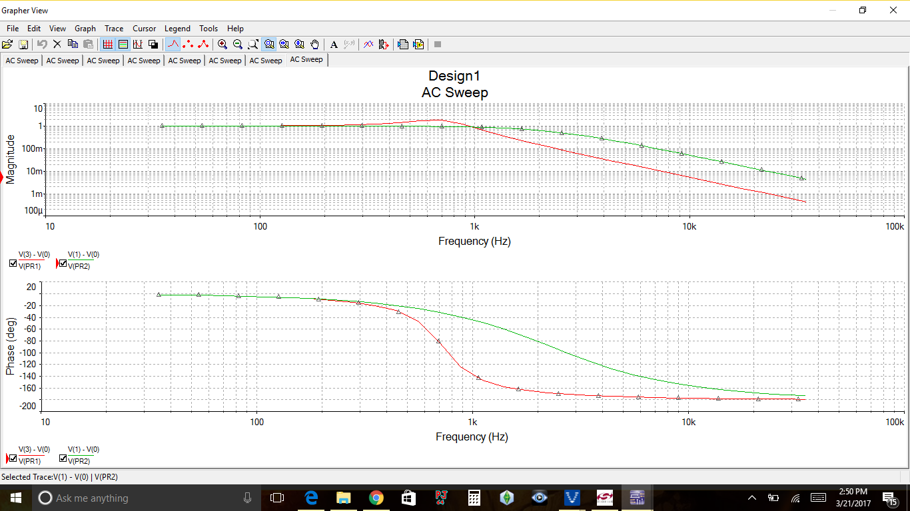

**Step 4 (Cut-off Frequency):** Power delivered to the load is proportional the *V*2 and/or *I*2. The point where the magnitude of the load voltage reaches is commonly referred to as the “half power point” or “cutoff frequency.” From your circuit simulations, identify the half-power frequency of each network. If you have a plot with dB units, locate the -3dB point (e.g. -3dB down from the low frequency gain for low pass filter and -3dB down from high frequency gain for high pass filter) since 20*log10(0.707) = -3dB. Note the frequency at this point. This is the cut-off frequency of your network. Please refer to Fig. 2.

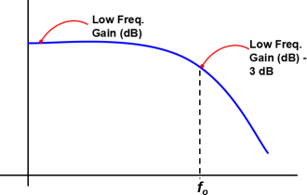         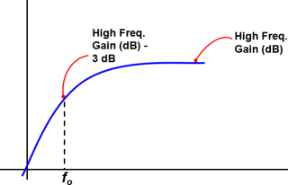

**(a)                                               (b)**

**Fig. 2: Location of cut-off frequency for (a) low pass filter and (b) high pass filter**

**Step 5** (**Numeric Simulations**): Using the **tf** function feature in MATLAB, load the Transfer Functions found earlier into MATLAB and save them as FL (Filter Low) and FH (Filter High).

a) Using MATLAB’s bode function, plot the frequency response of the two circuit networks and include the graphs in your lab book. Compare the graphs to those obtained by the circuit simulator and explain any discrepancies.

b) Using MATLAB, load an audio file, filter it, and play the results.

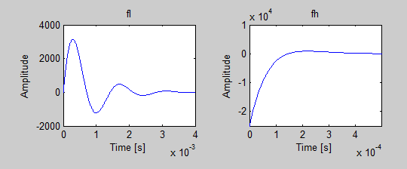

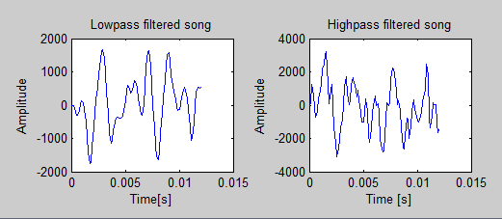

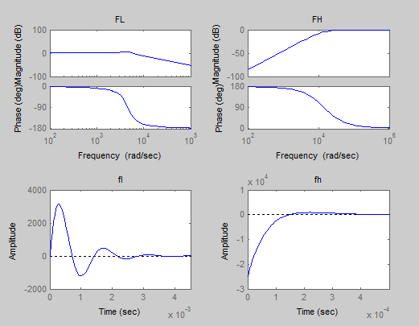

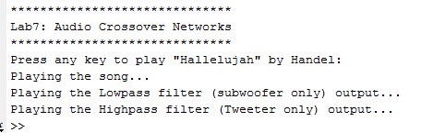

**Step 6** (**Hardware**): Construct the circuits shown in Figures 1 and 2. Use a generic (MID range) 8Ω speaker as the 8Ω resistor load in each circuit. Apply the 1V AC function generator as the input and vary the input frequency over the range from 35 Hz to 35 kHz. Document at what frequency each speaker is no longer producing an audible sound.

Subwoofer/ low pass filter is able to be audibly heard at 35 hz to roughly 16 khz depending on who is listening.

Tweeter/ high pass filter is able to be audibly heard from roughly 200 hz to 18.5 khz.

**ECE- 1270- Fall 2016 Lab 8: DC Power Supply**

**River Schenck 4/11/2017**

Purpose:

A DC power supply is one of the most commonly used devices in electronic circuits. This lab will introduce you to the inner workings of a transformer based power supply.

Equipment and Components:

1) Prototyping board

2) Function Generator

3) Oscilloscope

3) Diode 1N4001

4) Resistors: 10 kΩ potentiometer and others depending on your design

5) Capacitor: depending on your design

Background

The “oldest” and easiest to understand is the transformer based power supply, see Figure 1.  The transformer is used to scale the incoming AC signal (Vg) to the desired peak voltage (V1). A diode, a one-way gate, is then used to only allow part of the AC signal to pass (V2). 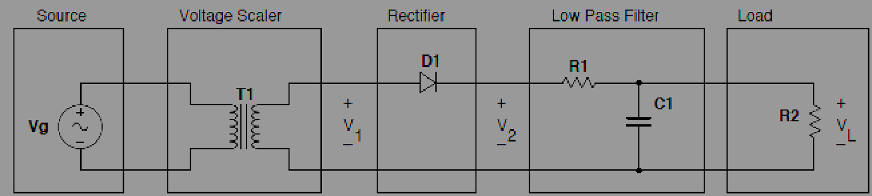    Fig. 1: Basic components of a DC Power Supply

Various diode configurations can be used to maximize the amount of signal allowed to pass through the diode configuration, see Figure 2.  Once through the diodes, the signal is then filtered using a Low Pass (LP) filter that removes the higher order harmonics.

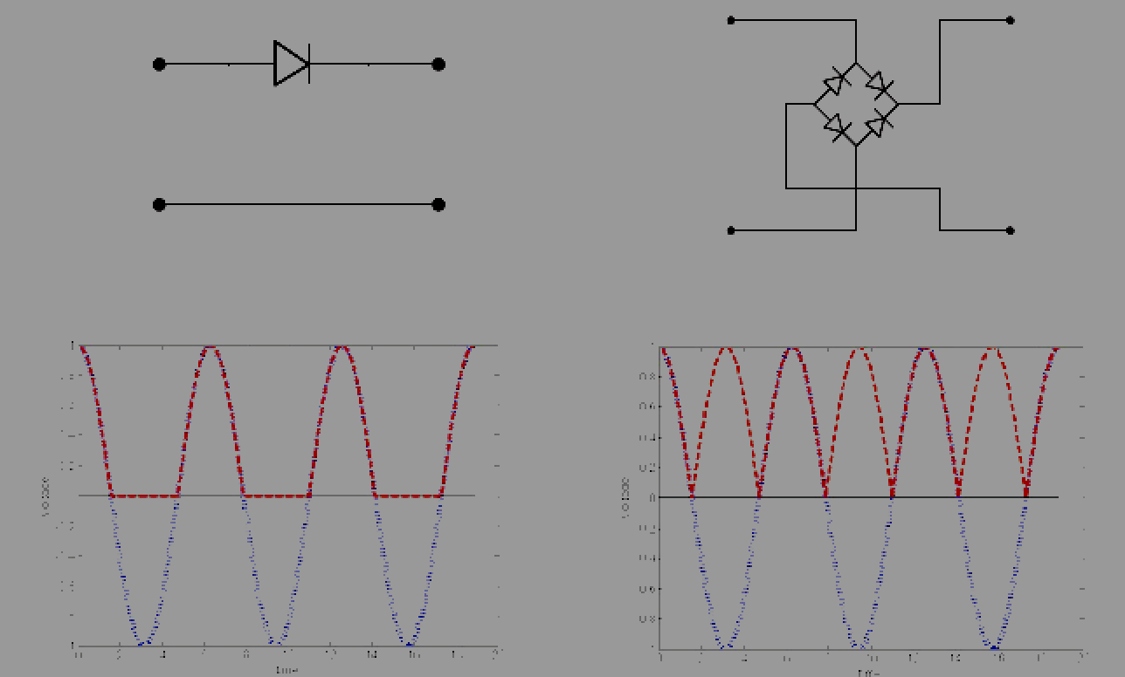

Fig. 2: Left: Half-wave rectifier; Right: full-wave rectifier.

Procedure:

1. Design and construct the RC low pass filter, assuming that it has a cutoff frequency of 1 kHz and a load of 5kΩ.

2. Test your low pass filter:

* Connect the filter (source side) to a 500 Hz sinusoidal function generator.
* Connect the filter (load side) to a 10 kΩ potentiometer set at 5 kΩ.
* Using the oscilloscope connect Channel 1 to the source and Channel 2 to the load.
* Sweep frequency and record the variation in the load voltage. Plot the variations in the magnitude of the output for at least 10 frequencies sampled equally between 100 Hz and 20 kHz.
* With the function generator, load, and oscilloscope still connected to the low pass filter, select the FFT (Fast Fourier Transform) option under the MATH function on the oscilloscope and document the Frequency Spectrum of the drive signal.

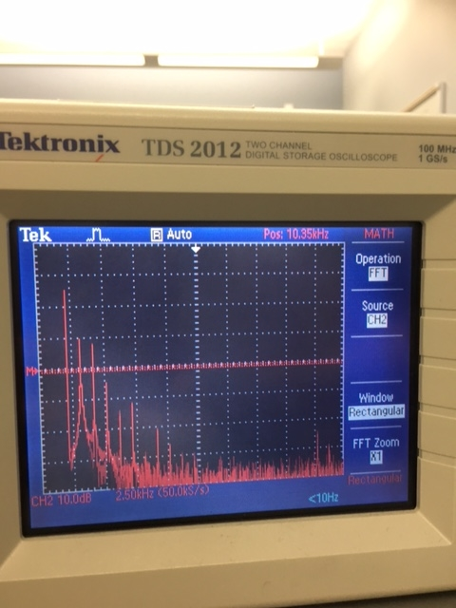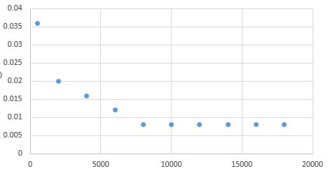

|  |  |  |  |  |  |  |  |  |  |  |
| --- | --- | --- | --- | --- | --- | --- | --- | --- | --- | --- |
| Freq.(Hz) | 500 | 2k | 4k | 6k | 8k | 10k | 12k | 14k | 16k | 18k |
| V(in) | 108m | 108m | 108m | 108m | 108m | 108m | 108m | 108m | 108m | 108m |
| V(out) | 36m | 20m | 16m | 12m | 8m | 8m | 8m | 8m | 8m | 8m |

3. Insert a diode between the filter and the source, remove the shunt capacitor from the low pass Filter, and observe the resulting output of the filter in both the time and frequencies domain (using the FFT function on the oscilloscope).

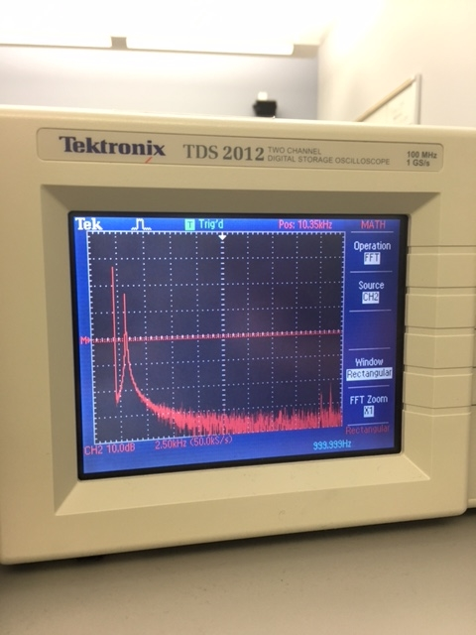

4. Add the shunt capacitor back into the filter and document the resulting filter output in both the time and frequency domain. Observe any changes.

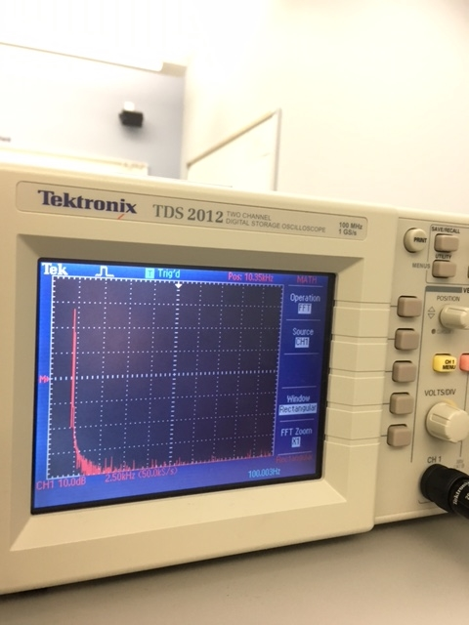

5. With everything in place, vary the drive frequency from 100 Hz to 20 kHz and observe the change in the response. Specifically identify over what frequency range does the “ripple” on the output of the power supply (the higher order harmonics)

* Appears insignificant (<10%).
* Appears to be a dominant component
* Appear to be the only component

6. Reset the function generator to a 500 Hz source and vary the load resistance (the 10 kΩ potentiometer). Specifically identify over what load resistance range the “ripple” on the output of the power supply (the higher order harmonics)

* Appears insignificant (<10%).
* Appears to be a dominant component
* Appear to be the only component

Conclusion Summarize your findings and what you learned during this lab.

We had problems with the fft. It appears that everybody in the lab had problems with it. Our filter was not working like it was supposed to and no one seemed to be able to make it work. The best answer to this solution is that there was a lot of impedance on the part that was not being filtered whereas before the impedance was across the whole thing.